

**SWD392**

**HOBBY CAR ANALYSIS**

**Class: SE1829-NJ**

**Lecturer: Nguyễn Thành Đạt - DatNT331**

**Group: 2**

| **Group member** | **Student Code** |
| --- | --- |
| Vũ Hồng Quang | HE176765 |
| Đinh Bảo Ngọc | HE182383 |
| Võ Đình Hưng | HE186864 |
| Hà Quốc Minh Đức | HE180232 |

# 

# 

# 

# 

# 

# 

**TABLE OF CONTENT**

**1. Introduction 3**

1.1. Overview of Children's Electric Vehicles 3

1.2. Technical description 3

**2. Use cases 4**

2.1. Use case overview 4

2.2. Use case diagram 6

2.3. Use case specification 6

**3. Non-functional requirements 18**

3.1 Performance 18

3.2 Safety 19

3.3 Reliability 19

3.4 Usability 19

3.5 Maintainability 20

3.6 Energy Efficiency 20

3.7 Durability 20

**4. Class Diagram 21**

4.1. Controller 21

4.2. ChangeModeButton 21

4.3. Switch 21

4.4. AcceleratorPedal 21

4.5. BrakePedal 22

4.6. SteeringWheel 22

4.7. Remote 22

4.8. EncodedMotor 22

4.9. Brake 22

4.10. DCMotor 22

4.11. Camera 22

**5. Multitasking System Design 23**

5.1 System Specification 23

5.2 System Design 27

5.3 System Implementation 29

# 

# 

# 

# 

# 1. Introduction

## 1.1. Overview of Children's Electric Vehicles

Children's electric vehicles have become increasingly popular and can be easily encountered and experienced in spacious areas such as plazas and parks. The prices of these electric vehicles for children vary, ranging from under 1 million VND to over 5 million VND, depending on factors such as size, load capacity, maximum speed, and additional features. Moreover, these vehicles are equipped with a remote control mode, allowing parents to operate them remotely.

## 1.2. Technical description

Children's electric vehicles are equipped with direct current (DC) motors for the wheels (DCMotors) and an encoded motor (EncodedMotor) for the steering system. The Encoded Motor is a type of motor capable of precisely controlling the angle of rotation and is integrated with the vehicle's steering wheel to manage directional movement. The vehicle includes a switch to determine whether the accelerator signal corresponds to forward or reverse motion. Additionally, these electric vehicles are fitted with a radio frequency (RF) remote control system, consisting of two small modules: a transmitter module (TX-Transmitter) and a receiver module (RX-Receiver). To enhance realism, the vehicle can be optionally equipped with a rear camera system, comprising a rear-facing camera and a display screen.

The electric vehicle operates in two modes: manual mode (self-driving) and remote control mode. In manual mode, the steering angle is directly controlled by signals from the steering wheel, the speed is regulated by signals from the accelerator pedal, and braking is managed by signals from the brake pedal. The rear camera system is activated only when the vehicle is in reverse mode.

# 

# 

# 

# 

# 

# 

# 2. Use cases

## 2.1. Use case overview

### 2.1.1. Start Vehicle

* Description: The child or parent activates the power switch to start the vehicle.
* Actors: Child, Parent.

### 2.1.2. Turn Off Vehicle

* Description: The child or parent deactivates the power switch to cease the vehicle’s operation.
* Actors: Child, Parent.

### 2.1.3. Switch Control Mode

* Description: Switches between manual mode (self-driving) and remote control mode.
* Actor: Parent.

### 2.1.4. Drive Manually

* Description: The child uses the steering wheel, accelerator, and brake to operate the vehicle.
* Actor: Child.

### 2.1.5. Steer Vehicle

* Description: The child rotates the steering wheel to control the direction of movement via the Encoded Motor.
* Actor: Child.

### 2.1.6. Control Speed

* Description: The child presses the accelerator pedal to increase speed or releases it to reduce speed.
* Actor: Child.

### 2.1.7. Brake Vehicle

* Description: The child presses the brake pedal to stop the vehicle.
* Actor: Child.

### 2.1.8. Switch Forward

* Description: Utilizes a switch to select whether the vehicle moves forward or backward.
* Actors: Child (in manual mode), Parent (in remote mode).

### 2.1.9. Switch Reverse

* Description: Utilizes a switch to select whether the vehicle moves forward or backward.
* Actors: Child (in manual mode), Parent (in remote mode).

### 2.1.10. Activate Rear Camera

* Description: The system automatically activates the rear camera and displays its image on the screen when the vehicle is in reverse mode.
* Actor: Vehicle System (automatically triggered).

### 2.1.11. Display Rear Camera Feed

* Description: The screen displays the image from the rear camera to assist with observation.
* Actor: Vehicle System.

### 2.1.12. Control Vehicle Remotely

* Description: The parent uses a remote control to manage the direction and speed of the vehicle via the TX-RX module.
* Actor: Parent.
* Extends Use Cases: 5, 6, 7, 8, 9.

## 2.2. Use case diagram

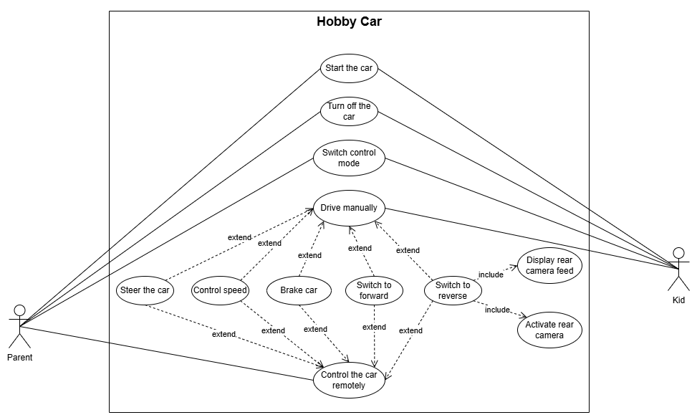

## 2.3. Use case specification

### 2.3.1. Start the car

| **Use Case ID** | UC-01 | **Use Case Name** | Start the car |
| --- | --- | --- | --- |
| **Created By** | DucHQM | **Created Date** | 23/03/2025 |
| **Primary Actor** | Child, Parent | **Secondary Actor** | N/A |
| **Description** | The child or parent turns on the power switch to start the vehicle. | | |
| **Pre-conditions** | - The vehicle is powered off.  - The battery is charged (at least 20% capacity). | | |
| **Post-conditions** | The vehicle is powered on and ready to operate in either manual or remote mode. | | |
| **Normal flow** | **1.0. Start the car**   1. The actor (child or parent) locates the power switch on the vehicle. 2. The actor flips the power switch to the "ON" position. 3. The system initializes, and the vehicle enters a standby state. | | |
| **Alternative flow** | **1.1. If the battery level is below 20%**   1. The system displays a low battery warning (if equipped). 2. The vehicle does not start, and the process ends. | | |
| **Exceptions** | **1.0.E1: If the power switch is faulty:**   1. The vehicle does not respond to the switch. 2. The actor must check the switch or contact support for repair.   **1.0.E2: If the system fails to initialize:**   1. The vehicle powers on but remains unresponsive. 2. The actor must turn off and retry or seek technical assistance. | | |
| **Priority** | High | | |
| **Frequency of use** | Every time the vehicle is used (multiple times daily). | | |
| **Business rules** | The vehicle must not start if the battery level is critically low to prevent damage. | | |
| **Other information** | None | | |
| **Assumptions** | None | | |

### 2.3.2. Turn off the car

| **Use Case ID** | UC-02 | **Use Case Name** | Turn off the car |
| --- | --- | --- | --- |
| **Created By** | DucHQM | **Created Date** | 23/03/2025 |
| **Primary Actor** | Child, Parent | **Secondary Actor** | N/A |
| **Description** | The child or parent turns off the power switch to stop the vehicle's operation. | | |
| **Pre-conditions** | - The vehicle is powered on. | | |
| **Post-conditions** | The vehicle is powered off and stops all operations. | | |
| **Normal flow** | **2.0. Turn off the car**   1. The actor locates the power switch. 2. The actor flips the switch to the "OFF" position. 3. The system shuts down. | | |
| **Alternative flow** | None | | |
| **Exceptions** | **2.0.E1: If the switch fails to turn off:**   1. The vehicle remains powered on. 2. The actor must disconnect the battery manually (if accessible) or seek assistance. | | |
| **Priority** | High | | |
| **Frequency of use** | At the end of each usage session. | | |
| **Business rules** | All systems (motors, camera, etc.) must stop within 2 seconds of shutdown. | | |
| **Other information** | None | | |
| **Assumptions** | None | | |

### 2.3.3. Switch control mode

| **Use Case ID** | UC-03 | **Use Case Name** | Switch control mode |
| --- | --- | --- | --- |
| **Created By** | DucHQM | **Created Date** | 23/03/2025 |
| **Primary Actor** | Parent, Child | **Secondary Actor** | N/A |
| **Description** | Switch between manual mode (self-driving) and remote control mode. | | |
| **Pre-conditions** | - The vehicle is powered on. | | |
| **Post-conditions** | The vehicle operates in the selected mode (manual or remote). | | |
| **Normal flow** | **3.0. Switch control mode**   1. The actor accesses the mode switch (on the vehicle or remote). 2. The actor selects either "Manual" or "Remote" mode. 3. The system updates the control mode accordingly. | | |
| **Alternative flow** | **3.1. If the mode switch fails:**   1. The vehicle remains in the default mode (manual). 2. The process ends. | | |
| **Exceptions** | **3.0.E1: If the remote signal interferes with mode switching:**   1. The system fails to recognize the mode change. 2. The parent must power off the vehicle and retry. | | |
| **Priority** | Medium | | |
| **Frequency of use** | Once or twice per session, depending on usage scenario. | | |
| **Business rules** | None | | |
| **Other information** | None | | |
| **Assumptions** | None | | |

### 2.3.4. Drive manually

| **Use Case ID** | UC-04 | **Use Case Name** | Drive manually |
| --- | --- | --- | --- |
| **Created By** | DucHQM | **Created Date** | 23/03/2025 |
| **Primary Actor** | Child | **Secondary Actor** | N/A |
| **Description** | The child uses the steering wheel, accelerator, and brake to control the vehicle. | | |
| **Pre-conditions** | The vehicle is powered on and in manual mode. | | |
| **Post-conditions** | The vehicle moves according to the child’s inputs. | | |
| **Normal flow** | **4.0. Drive manually**   1. The child sits in the driver’s seat. 2. The child uses the steering wheel, accelerator, and brake as needed. 3. The vehicle responds to the inputs in real-time. | | |
| **Alternative flow** | **4.1. If the battery runs out during operation:**   1. The vehicle slows down and stops. 2. The process ends. | | |
| **Exceptions** | **4.0.E1: If a motor malfunctions:**   1. The vehicle stops or moves erratically. 2. The child must turn off the vehicle (UC-02) and notify the parent. | | |
| **Priority** | High | | |
| **Frequency of use** | Continuous during manual mode operation. | | |
| **Business rules** | Speed is limited to 5 km/h for safety. | | |
| **Other information** | None | | |
| **Assumptions** | None | | |

## 

### 2.3.5. Steer the car

| **Use Case ID** | UC-05 | **Use Case Name** | Steer the car |
| --- | --- | --- | --- |
| **Created By** | DucHQM | **Created Date** | 23/03/2025 |
| **Primary Actor** | Child, Parent | **Secondary Actor** | N/A |
| **Description** | The child turns the steering wheel in manual mode, or the parent uses the remote control to steer the vehicle, controlling the direction of movement via the Encoded Motor. | | |
| **Pre-conditions** | The vehicle is powered on and moving (in manual mode for Child or remote mode for Parent). | | |
| **Post-conditions** | The vehicle changes direction based on the steering input from the child or parent. | | |
| **Normal flow** | **5.0. Steer the car**   1. The child turns the steering wheel left or right (in manual mode), or the parent adjusts the steering control on the remote (in remote mode). 2. The Encoded Motor adjusts the wheels accordingly. 3. The vehicle follows the new direction. | | |
| **Alternative flow** | **5.1. If the Encoded Motor fails:**   1. The vehicle continues in a straight line. 2. The child must stop the vehicle manually, or the parent must stop it via remote. | | |
| **Exceptions** | **5.0.E1:If the remote steering signal fails (remote mode):**   1. The vehicle does not respond to the parent’s input. 2. The parent must stop the vehicle via remote or switch to manual mode. | | |
| **Priority** | High | | |
| **Frequency of use** | Frequent during manual or remote driving. | | |
| **Business rules** | Steering response time must be under 0.5 seconds in both modes. | | |
| **Other information** | None | | |
| **Assumptions** | None | | |

### 2.3.6. Control speed

| **Use Case ID** | UC-06 | **Use Case Name** | Control speed |
| --- | --- | --- | --- |
| **Created By** | DucHQM | **Created Date** | 23/03/2025 |
| **Primary Actor** | Child, Parent | **Secondary Actor** | N/A |
| **Description** | The child presses the accelerator to increase speed or releases it to slow down in manual mode, or the parent adjusts speed via the remote control in remote mode. | | |
| **Pre-conditions** | The vehicle is powered on (in manual mode for Child or remote mode for Parent). | | |
| **Post-conditions** | The vehicle’s speed adjusts based on the accelerator input from the child or the remote input from the parent. | | |
| **Normal flow** | **6.0. Control speed**   1. The child presses the accelerator pedal (manual mode), or the parent presses the speed control button on the remote (remote mode). 2. The DC Motor increases speed proportionally. 3. The child releases the pedal, or the parent releases the button, to slow down. | | |
| **Alternative flow** | **6.1: If the accelerator gets stuck (manual mode):**   1. The vehicle maintains speed. 2. The child must use the brake.   **6.2: If the remote speed control fails (remote mode):**   1. The vehicle maintains its current speed. 2. The parent must stop the vehicle via remote. | | |
| **Exceptions** | **6.0.E1: If the DC Motor overheats:**   1. The vehicle slows down or stops unexpectedly. 2. The child or parent must turn off the vehicle and wait for it to cool down. | | |
| **Priority** | High | | |
| **Frequency of use** | Frequent during manual or remote driving. | | |
| **Business rules** | Maximum speed is capped at 5 km/h | | |
| **Other information** | None | | |
| **Assumptions** | None | | |

### 2.3.7. Brake car

| **Use Case ID** | UC-07 | **Use Case Name** | Brake car |
| --- | --- | --- | --- |
| **Created By** | DucHQM | **Created Date** | 23/03/2025 |
| **Primary Actor** | Child, Parent | **Secondary Actor** | N/A |
| **Description** | The child presses the brake pedal to stop the vehicle in manual mode, or the parent uses the remote control to stop the vehicle in remote mode. | | |
| **Pre-conditions** | The vehicle is moving (in manual mode for Child or remote mode for Parent). | | |
| **Post-conditions** | The vehicle comes to a complete stop. | | |
| **Normal flow** | **7.0. Brake car**   1. The child presses the brake pedal (manual mode), or the parent activates the stop/brake function on the remote (remote mode). 2. The DC Motor stops, and the vehicle halts. | | |
| **Alternative flow** | **7.1. If the brake fails (manual mode):**   1. The vehicle continues moving. 2. The child must turn off the vehicle.   **7.2. If the remote brake signal fails (remote mode):**   1. The vehicle continues moving. 2. The parent must turn off the vehicle or switch to manual mode. | | |
| **Exceptions** | None | | |
| **Priority** | High | | |
| **Frequency of use** | As needed during manual or remote driving. | | |
| **Business rules** | Stopping distance must be under 0.5 meters at maximum speed in both modes. | | |
| **Other information** | None | | |
| **Assumptions** | None | | |

### 2.3.8. Switch to forward

| **Use Case ID** | UC-08 | **Use Case Name** | Switch to forward |
| --- | --- | --- | --- |
| **Created By** | DucHQM | **Created Date** | 23/03/2025 |
| **Primary Actor** | Child, Parent | **Secondary Actor** | N/A |
| **Description** | The child or parent uses the switch (on the vehicle or remote) to set the vehicle to move forward. | | |
| **Pre-conditions** | The vehicle is powered on (in manual mode for Child or remote mode for Parent). | | |
| **Post-conditions** | The vehicle is set to move forward based on the switch position | | |
| **Normal flow** | **8.0. Switch to forward**   1. The child flips the forward/reverse switch to "Forward" on the vehicle (manual mode), or the parent toggles the direction to "Forward" on the remote (remote mode). 2. The system updates the motor direction to forward. | | |
| **Alternative flow** | None | | |
| **Exceptions** | **8.0.E1: If the switch is defective (manual mode):**   1. The vehicle remains in its current direction (e.g., reverse or stopped). 2. The child must power off (UC-011) and inspect the switch.   **8.0.E2: If the remote direction signal fails (remote mode):**   1. The vehicle does not change to forward direction. 2. The parent must retry or turn off the vehicle (UC-011). | | |
| **Priority** | Medium | | |
| **Frequency of use** | Occasional, depending on driving needs in either mode. | | |
| **Business rules** | Switching to forward does not trigger the rear camera. | | |
| **Other information** | None | | |
| **Assumptions** | None | | |

### 2.3.9. Switch to reverse

| **Use Case ID** | UC-09 | **Use Case Name** | Switch to reverse |
| --- | --- | --- | --- |
| **Created By** | DucHQM | **Created Date** | 23/03/2025 |
| **Primary Actor** | Child, Parent | **Secondary Actor** | N/A |
| **Description** | The child or parent uses the switch (on the vehicle or remote) to set the vehicle to move backward, triggering the rear camera system. | | |
| **Pre-conditions** | The vehicle is powered on (in manual mode for Child or remote mode for Parent). | | |
| **Post-conditions** | The vehicle is set to move backward based on the switch position, and the rear camera is activated with its feed displayed. | | |
| **Normal flow** | **9.0. Switch to reverse**   1. The child flips the forward/reverse switch to "Reverse" on the vehicle (manual mode), or the parent toggles the direction to "Reverse" on the remote (remote mode). 2. The system updates the motor direction to reverse. 3. The system triggers UC-10 (Activate Rear Camera) and UC-11 (Display Rear Camera Feed). | | |
| **Alternative flow** | None | | |
| **Exceptions** | **9.0.E1: If the switch is defective (manual mode):**   1. The vehicle remains in its current direction (e.g., forward or stopped). 2. The child must power off and inspect the switch.   **9.0.E2: If the remote direction signal fails (remote mode):**   1. The vehicle does not change to forward direction. 2. The parent must retry or turn off the vehicle. | | |
| **Priority** | Medium | | |
| **Frequency of use** | Occasional, depending on driving needs in either mode. | | |
| **Business rules** | Switching to reverse must trigger the rear camera and display its feed in both manual and remote modes. | | |
| **Other information** | None | | |
| **Assumptions** | None | | |

### 2.3.10. Activate rear camera

| **Use Case ID** | UC-10 | **Use Case Name** | Activate rear camera |
| --- | --- | --- | --- |
| **Created By** | DucHQM | **Created Date** | 23/03/2025 |
| **Primary Actor** | Child, Parent | **Secondary Actor** | N/A |
| **Description** | The system automatically activates the rear camera when the vehicle is set to reverse mode. | | |
| **Pre-conditions** | The vehicle is in reverse mode (UC-09 triggered). | | |
| **Post-conditions** | The rear camera is active and ready to send its feed. | | |
| **Normal flow** | **10.0. Activate rear camera**   1. The system detects reverse mode activation from UC-007b. 2. The rear camera turns on automatically. | | |
| **Alternative flow** | None | | |
| **Exceptions** | **10.0.E1: If the camera fails:**   1. The system skips to normal operation without camera activation.   **10.0.E2: If the camera wiring is disconnected:**   1. The system detects no camera signal. 2. The camera remains inactive, but reverse mode continues. | | |
| **Priority** | Medium | | |
| **Frequency of use** | Whenever reverse mode is used. | | |
| **Business rules** | Camera activation must occur within 1 second of reverse mode activation. | | |
| **Other information** | None | | |
| **Assumptions** | None | | |

### 2.3.11. Display rear camera feed

| **Use Case ID** | UC-11 | **Use Case Name** | Display rear camera feed |
| --- | --- | --- | --- |
| **Created By** | DucHQM | **Created Date** | 23/03/2025 |
| **Primary Actor** | Child, Parent | **Secondary Actor** | N/A |
| **Description** | The screen displays the image from the rear camera to assist with observation during reverse mode. | | |
| **Pre-conditions** | The rear camera is activated (UC-10 triggered). | | |
| **Post-conditions** | The rear view is visible on the screen. | | |
| **Normal flow** | **11.0. Display rear camera feed**   1. The system receives the camera feed from UC-10. 2. The screen displays the live feed. | | |
| **Alternative flow** | None | | |
| **Exceptions** | **11.0.E1:If the screen malfunctions:**   1. The feed is not displayed, but the vehicle operates normally in reverse.   **11.0.E2: If the screen power fails:**   1. The screen goes blank. 2. The system continues reverse operation without visual feedback. | | |
| **Priority** | Medium | | |
| **Frequency of use** | Whenever reverse mode is used. | | |
| **Business rules** | Display resolution must be at least 320x240 pixels. | | |
| **Other information** | None | | |
| **Assumptions** | None | | |

### 2.3.12. Control the car remotely

| **Use Case ID** | UC-12 | **Use Case Name** | Control the car remotely |
| --- | --- | --- | --- |
| **Created By** | DucHQM | **Created Date** | 23/03/2025 |
| **Primary Actor** | Parent | **Secondary Actor** | N/A |
| **Description** | The parent uses the remote control to steer and control the speed of the vehicle via the TX-RX module. | | |
| **Pre-conditions** | The vehicle is in remote mode and powered on. | | |
| **Post-conditions** | The vehicle moves according to the parent’s remote inputs. | | |
| **Normal flow** | **12.0. Control the car remotely**   1. The parent activates the remote control. 2. The parent uses the remote to steer, accelerate, or brake (extends UC-05, UC-06, UC-07, UC-08, UC-09). 3. The vehicle responds via the RX module. | | |
| **Alternative flow** | None | | |
| **Exceptions** | **12.0.E1:If the TX module battery dies:**   1. The remote becomes unresponsive. 2. The vehicle stops, and the parent must replace the battery or switch to manual mode.   **12.0.E2: If the signal is lost:**   1. The vehicle stops automatically. | | |
| **Priority** | High | | |
| **Frequency of use** | Continuous during remote mode. | | |
| **Business rules** | Remote range must be at least 20 meters. | | |
| **Other information** | None | | |
| **Assumptions** | None | | |

# 3. Non-functional requirements

## 3.1. Performance

* Maximum Speed:
  + Description: The vehicle must maintain a maximum speed that is safe for children.
  + Metric: Maximum speed of 5 km/h in manual mode and 3 km/h in remote control mode.
* Motor Response Time:
  + Description: The motor must respond promptly to signals from the accelerator or remote control.
  + Metric: Response time of less than 0.5 seconds from the moment the accelerator or brake is activated to motor operation.
* Continuous Operating Time:
  + Description: The vehicle must operate for an extended period before requiring a battery recharge.
  + Metric: Minimum continuous operating time of 2 hours under maximum load conditions.

## 3.2. Safety

* Maximum Load Capacity:
  + Description: The vehicle must support the weight of children without sustaining damage.
  + Metric: Maximum load capacity of 40 kg (suitable for children aged 3–8 years).
* Emergency Braking:
  + Description: The braking system must stop the vehicle immediately upon activation.
  + Metric: Maximum stopping distance of 0.5 meters at a speed of 5 km/h.
* Remote Control Range:
  + Description: The remote control must function reliably within a specified distance to enable parental supervision.
  + Metric: Minimum range of 20 meters in unobstructed conditions.
* Fire-Resistant Materials:
  + Description: The vehicle’s shell and electrical components must be constructed from non-flammable materials.
  + Metric: Compliance with UL94 V-0 fire resistance standard.

## 3.3. Reliability

* Motor Failure Rate:
  + Description: The motor must operate consistently without failures under normal conditions.
  + Metric: Failure rate of less than 1% over 500 hours of operation.
* Battery Lifespan:
  + Description: The battery must retain performance across multiple charge cycles.
  + Metric: Minimum of 300 charge cycles with battery capacity not dropping below 80%.
* RF Signal Stability:
  + Description: The remote signal transmission and reception modules must function without interruption.
  + Metric: Signal loss rate of less than 0.5% within a 20-meter range.

## 3.4. Usability

* Learning Time:
  + Description: Children and parents must quickly become familiar with operating the vehicle.
  + Metric: Maximum learning time of 10 minutes for children and 5 minutes for parents.
* Vehicle Weight:
  + Description: The vehicle must be lightweight for easy transport or storage.
  + Metric: Maximum weight of 15 kg (including battery and accessories).
* Steering Sensitivity:
  + Description: The steering wheel must be easy to turn and provide accurate response to steering angles.
  + Metric: Maximum steering angle deviation of ±5 degrees relative to the Encoded Motor signal.

## 3.5. Maintainability

* Battery Replacement Time:
  + Description: Battery replacement must be quick and require minimal tools.
  + Metric: Maximum replacement time of 5 minutes using a standard screwdriver.
* Firmware Update Capability:
  + Description: The control system must support updates to fix bugs or enhance features.
  + Metric: Firmware update time of less than 10 minutes via a USB port.

## 3.6. Energy Efficiency

* Battery Capacity:
  + Description: The battery must provide sufficient energy to power all vehicle functions.
  + Metric: Minimum capacity of 12V/7Ah (lead-acid or lithium-ion battery).
* Charging Time:
  + Description: The battery must fully charge within a reasonable timeframe.
  + Metric: Maximum charging time of 6 hours from 0% to 100%.

## 3.7. Durability

* Average Lifespan:
  + Description: The vehicle must remain functional over an extended period without significant damage.
  + Metric: Minimum lifespan of 3 years with an average usage frequency of 2 hours per day.
* Impact Resistance:
  + Description: The vehicle’s shell must withstand minor impacts during use.
  + Metric: Capable of withstanding a 10 kg impact from a height of 0.5 meters.

# 

# 4. Class Diagram

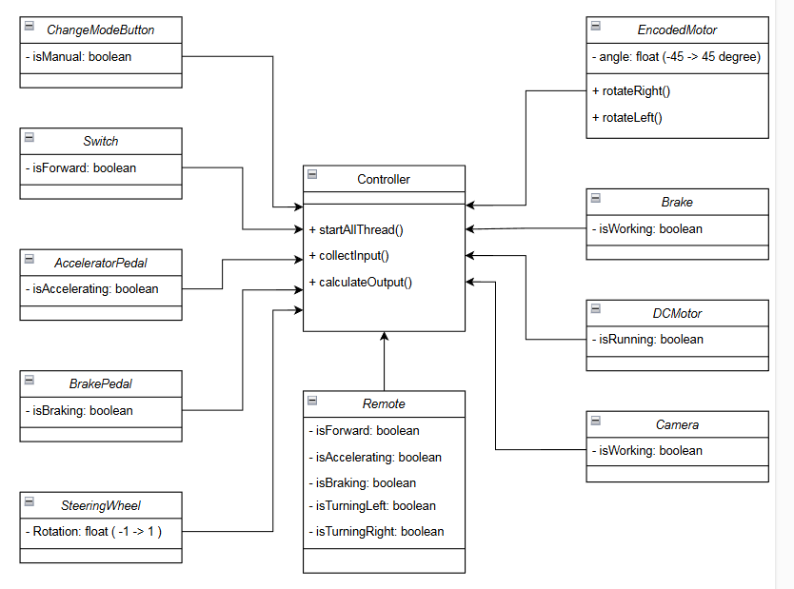

## 4.1. Controller

* Đây là class trung tâm, có nhiệm vụ điều khiển toàn bộ hệ thống.
* **Phương thức**:  
  + startAllThread(): Bắt đầu các luồng xử lý.  
  + collectInput(): Thu thập dữ liệu đầu vào từ các thiết bị như bàn đạp, vô lăng, điều khiển từ xa, v.v.  
  + calculateOutput(): Tính toán đầu ra dựa trên dữ liệu đầu vào.

## 4.2. ChangeModeButton

* **Thuộc tính**:  
  + isManual: boolean: Xác định chế độ điều khiển (tự động hay thủ công).

## 4.3. Switch

* **Thuộc tính**:  
  + isForward: boolean: Xác định hướng di chuyển (tiến hoặc lùi).

## 4.4. AcceleratorPedal

* **Thuộc tính**:  
  + isAccelerating: boolean: Kiểm tra xem bàn đạp ga có đang được nhấn hay không.

## 4.5. BrakePedal

* **Thuộc tính**:  
  + isBraking: boolean: Kiểm tra xem bàn đạp phanh có đang được nhấn hay không.

## 4.6. SteeringWheel

* **Thuộc tính**:  
  + Rotation: float (-1 -> 1): Giá trị quay của vô lăng (-1 là quay hết về bên trái, 1 là quay hết về bên phải).

## 4.7. Remote

* **Thuộc tính**:  
  + isForward: boolean: Điều khiển tiến/lùi.  
  + isAccelerating: boolean: Điều khiển tăng tốc.  
  + isBraking: boolean: Điều khiển phanh.  
  + isTurningLeft: boolean: Điều khiển rẽ trái.  
  + isTurningRight: boolean: Điều khiển rẽ phải.

## 4.8. EncodedMotor

* **Thuộc tính**:  
  + angle: float (-45 -> 45 degree): Góc quay của động cơ (có thể xoay từ -45 đến 45 độ).
* **Phương thức**:  
  + rotateRight(): Xoay động cơ sang phải.  
  + rotateLeft(): Xoay động cơ sang trái.

## 4.9. Brake

* **Thuộc tính**:  
  + isWorking: boolean: Kiểm tra xem phanh có hoạt động hay không.

## 4.10. DCMotor

* **Thuộc tính**:  
  + isRunning: boolean: Kiểm tra xem động cơ có đang chạy hay không.

## 4.11. Camera

* **Thuộc tính**:  
  + isWorking: boolean: Kiểm tra xem camera có hoạt động hay không.

# 5. Multitasking System Design

## 5.1 System Specification

The Figure 4-1 is the block diagram of the complete system. The accelerator pedal, steering wheel, brake pedal, switch carry out the signals and the remote control sends orders. The controller acquires this data to control the DCMotor, encoded motor, brake and camera. Thus, we have the context diagram as shown in Figure 4-3.

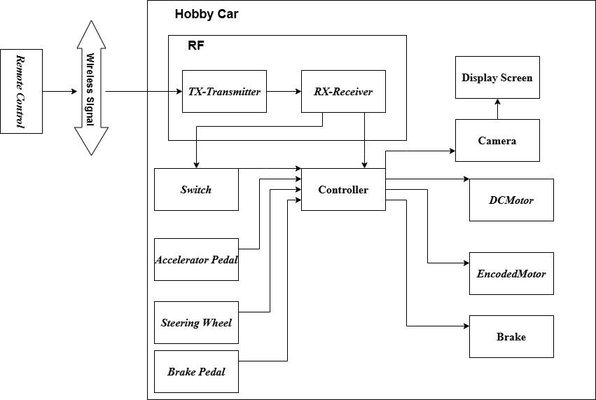

Figure 4-1 Complete Block Diagram

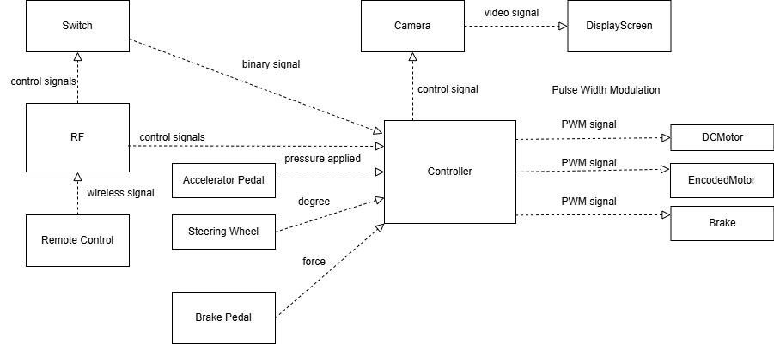

Figure 4-2 Hobby Car Block Diagram

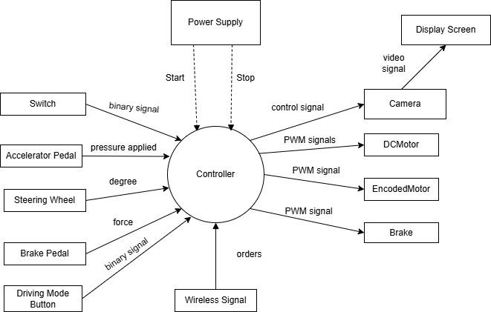

Figure 4-3 Hobby Car Context Diagram

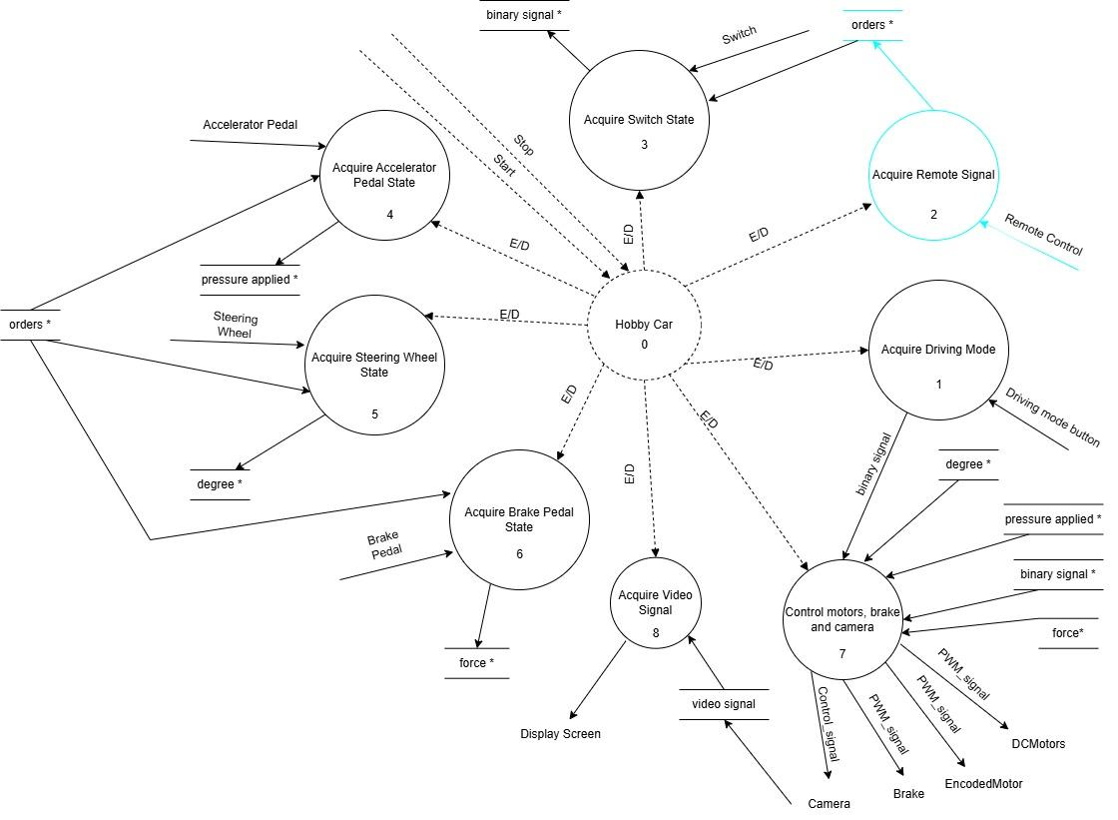

Figure 4-4 Preliminary diagram of Hobby Car control system

The Hobby Car will be designed to operate in manual mode and remote-controlled mode. In manual mode, direct user inputs from pedals and the steering wheel dictate the vehicle’s movement. In remote-controlled mode, commands received from the remote control module override manual inputs, ensuring seamless operation under both conditions.

The preliminary diagram can now be derived (Figure 4-4)

### Process 1: Acquiring Driving Mode

The system begins by determining the current driving mode based on user input. A dedicated button allows the user to switch between manual and remote control operation. When activated, this button sends a binary signal to the controller, which then sets the appropriate driving mode.

### Process 2: Acquiring Remote Signals

In remote-controlled mode, the remote control system receives wireless signals from an external transmitter, allowing for remote operation of the hobby car. These signals encompass acceleration, braking, and directional movement commands, which are interpreted by the controller. The received data is verified for integrity before being processed into actionable motor control signals. This process ensures minimal latency and prevents erroneous commands, thereby enhancing reliability and user experience. In manual mode, this process is disabled.

### Process 3: Acquiring Switch State

The switch mechanism determines the movement direction of the hobby car, allowing it to transition between forward and reverse motion. A binary signal representing the switch state is continuously monitored by the controller. When a change in switch position is detected, the controller updates the motor control signals accordingly, ensuring a smooth and controlled transition. To prevent abrupt directional shifts that may damage mechanical components, a brief delay mechanism is implemented to introduce a buffer period between transitions.

### Process 4: Acquiring Accelerator Pedal State

The accelerator pedal is equipped with a pressure-sensitive sensor that measures the applied force. This force is converted into an electrical signal and transmitted to the controller. A processing algorithm maps the pressure intensity to a corresponding PWM (Pulse Width Modulation) value, which determines the speed of the DC motors. The system employs a gradual acceleration function to enhance driving stability, reducing sudden speed fluctuations and ensuring a smooth driving experience.

### Process 5: Acquiring Steering Wheel State

The steering wheel’s angular position is measured using an encoded motor sensor. This sensor continuously tracks the wheel's degree of rotation and sends the data to the controller. The system interprets this data to adjust the front wheels' orientation, ensuring real-time responsiveness to the user’s input.

### Process 6: Acquiring Brake Pedal State

The brake pedal is equipped with a force sensor that measures the pressure applied during braking. This data is transmitted to the controller, where it is analyzed to generate an appropriate braking response. A higher applied force results in stronger braking action, ensuring proportional deceleration. The system includes an emergency braking mechanism, which detects sudden forceful presses and activates maximum braking power. Additionally, safety logic prevents simultaneous acceleration and braking inputs from conflicting, prioritizing braking in such cases.

### Process 7: Controlling Motors, Brakes, and Camera

This process encompasses the core execution of movement commands, integrating multiple control functions to manage the toy car’s operations. Based on acquired input data from previous processes, the controller generates PWM signals to regulate the speed and direction of the DC motors. The brake system is similarly controlled through proportional force adjustments. Additionally, the camera system, if present, captures live video feed, which can be displayed on an external screen for monitoring purposes. This integration ensures that all components work cohesively to provide a smooth and responsive driving experience.

### Process 8: Acquiring Video Signal

If the switch mode is ‘reverse’, the hobby car’s onboard camera captures real-time video signals, which are transmitted to a display screen. This process involves continuous video streaming and signal processing to maintain a stable and clear output. The controller manages video encoding and transmission efficiency, ensuring minimal latency and optimal resolution. This feature is particularly useful, providing the user with a live visual feed to enhance navigation and control. If the switch mode is ‘forward’, this process is disabled.

Now, a multitask design of the system can be carried out. It is presented using a DARTS (Design Approach for Real-Time Systems) diagram.

## 5.2 System Design

Each process in the SART diagram will be passed into a task, the data flow and event (mode) flow will be implemented as the memory modules.

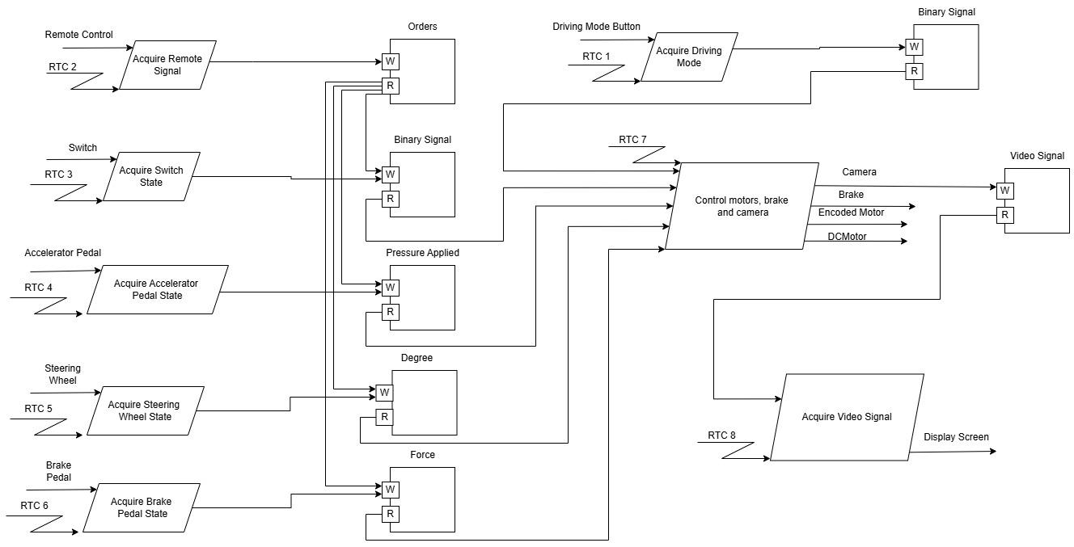

Figure 4-5 Hobby Car DARTS diagram

**Task 1** acquires driving mode and sends a binary signal to the controller.

If the mode is ‘remote-controlled’, **Task 2** acquires orders from the remote controller and sends them to the desired destination. If the mode is ‘manual’, this task is disabled.

**Task 3** acquires the binary signal from the Switch and sends it to the controller to determine the movement direction of the toy car.

**Task 4** acquires the pressure applied on the accelerator pedal and sends it directly to the controller to determine the speed of the DC motors. In remote-controlled mode, the controller receives order from the remote controller, this task is disabled.

**Task 5** acquires the wheel's degree of rotation that is then sent directly to the controller. In remote-controlled mode, the controller receives order from the remote controller, this task is disabled.

**Task 6** acquires the pressure applied during braking and sends it directly to the controller to perform braking. In remote-controlled mode, the controller receives order from the remote controller, this task is disabled.

**In task 7,** the controller generates PWM signals to regulate the speed and direction of the DC motors.

**Task 8** acquires the video signal and sends it to the display screen. If the switch mode is ‘forward’, this task is disabled.

## 

## 5.3 System Implementation

### 5.3.1. Class ChangeModeButton

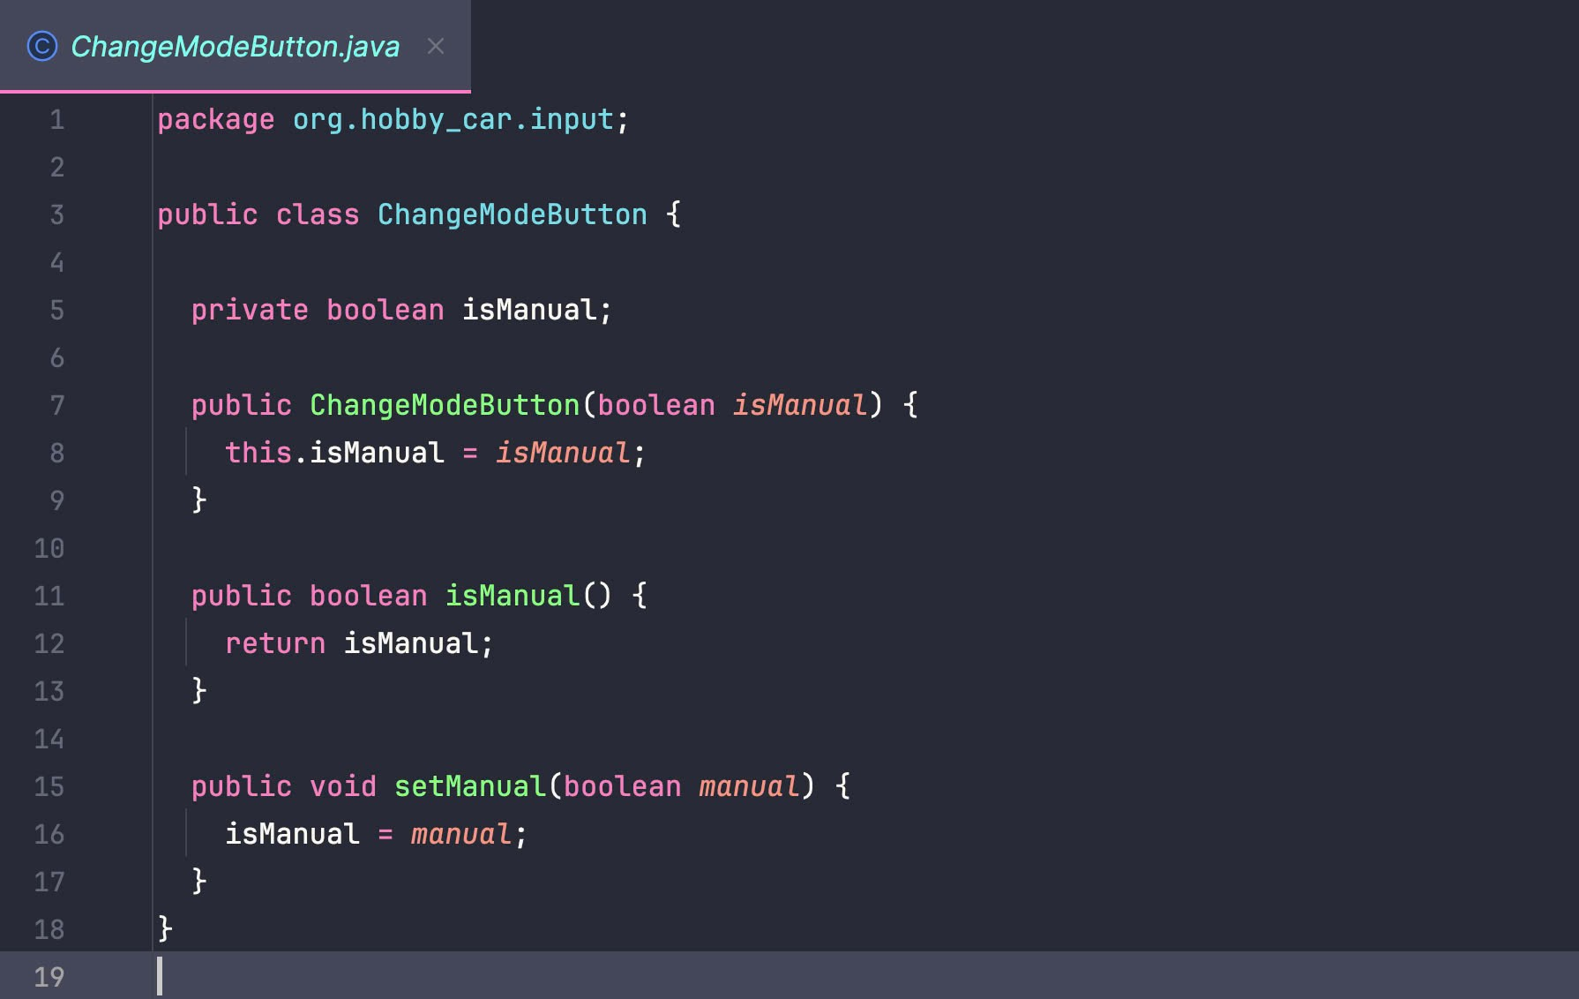

### 5.3.2. Class BrakePedal

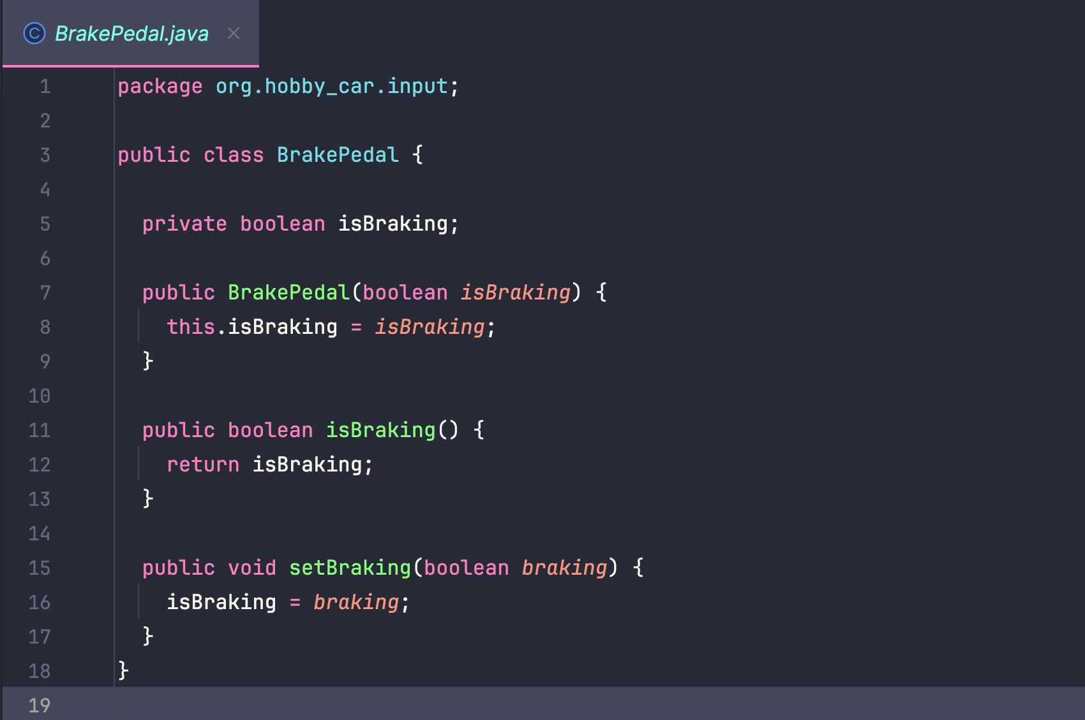

### 5.3.3. Class Accelerator Pedal

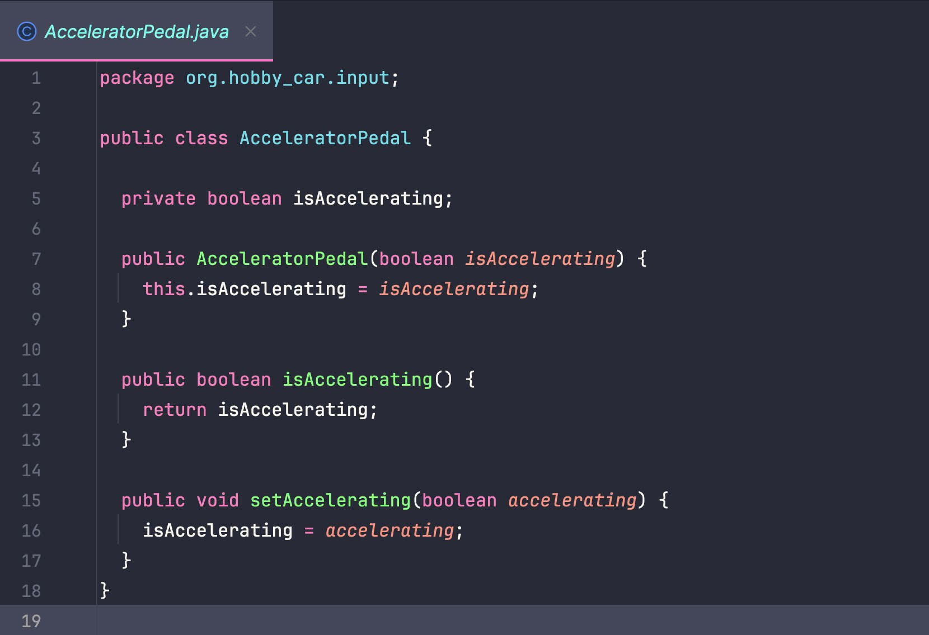

### 5.3.4. Class Accelerator Switch

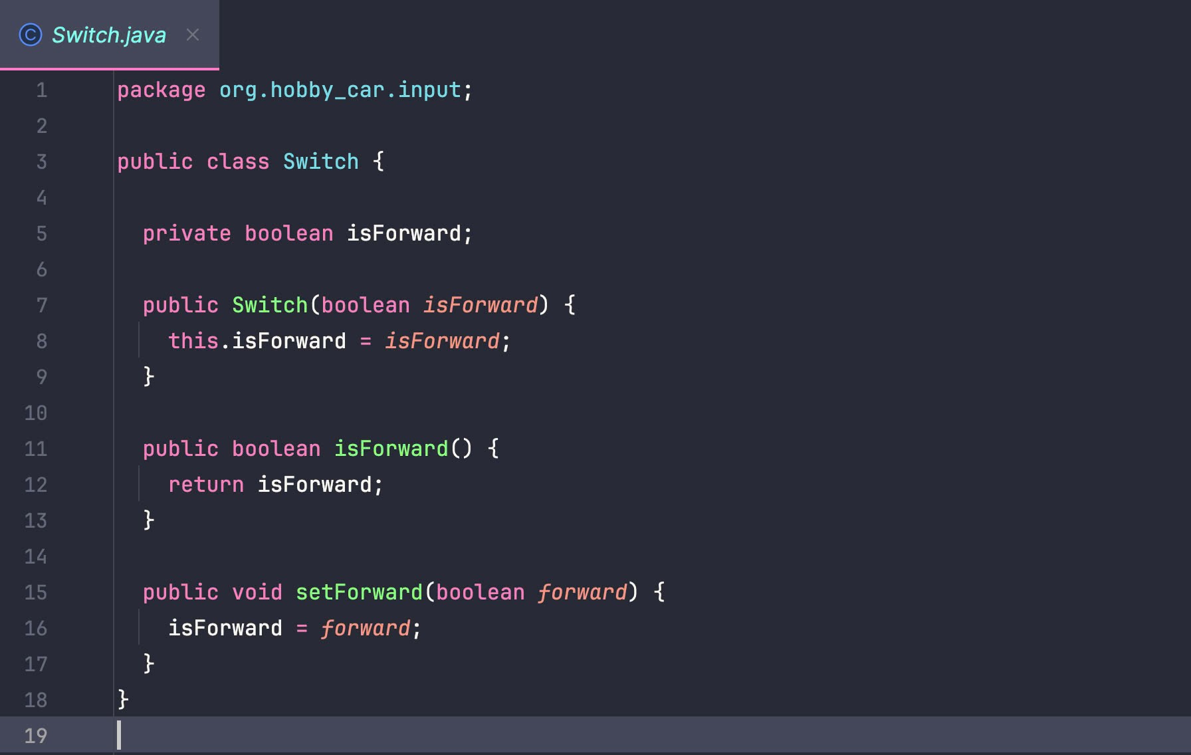

### 

### 5.3.5. Class Remote

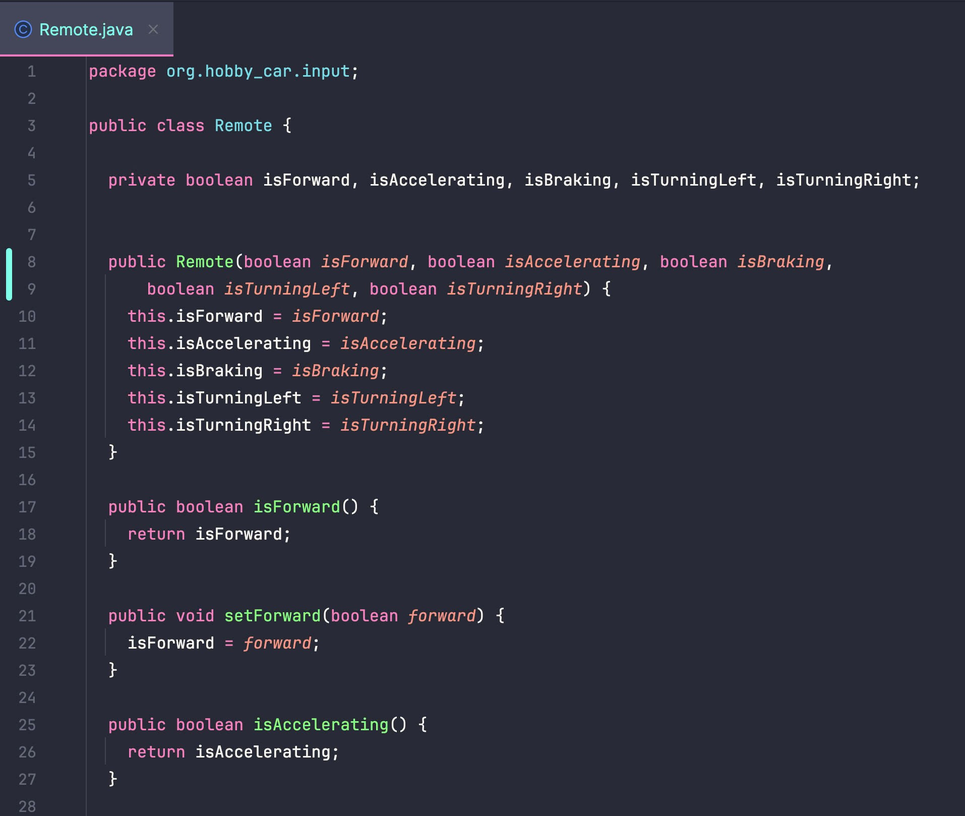

### 5.3.6. Class SteeringWheel

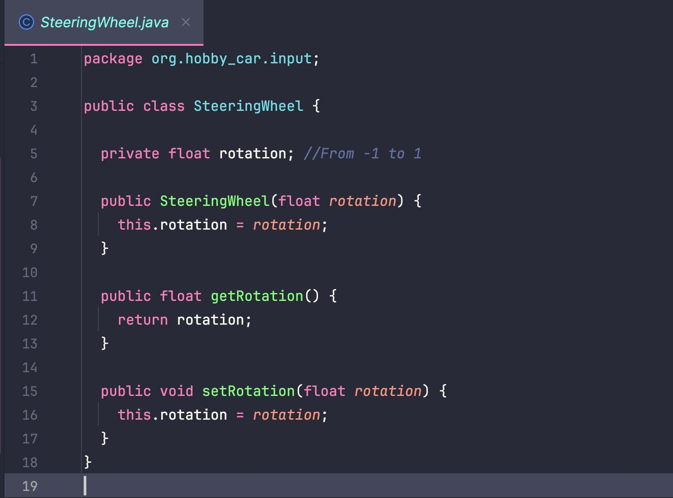

### 5.3.7. Class Brake

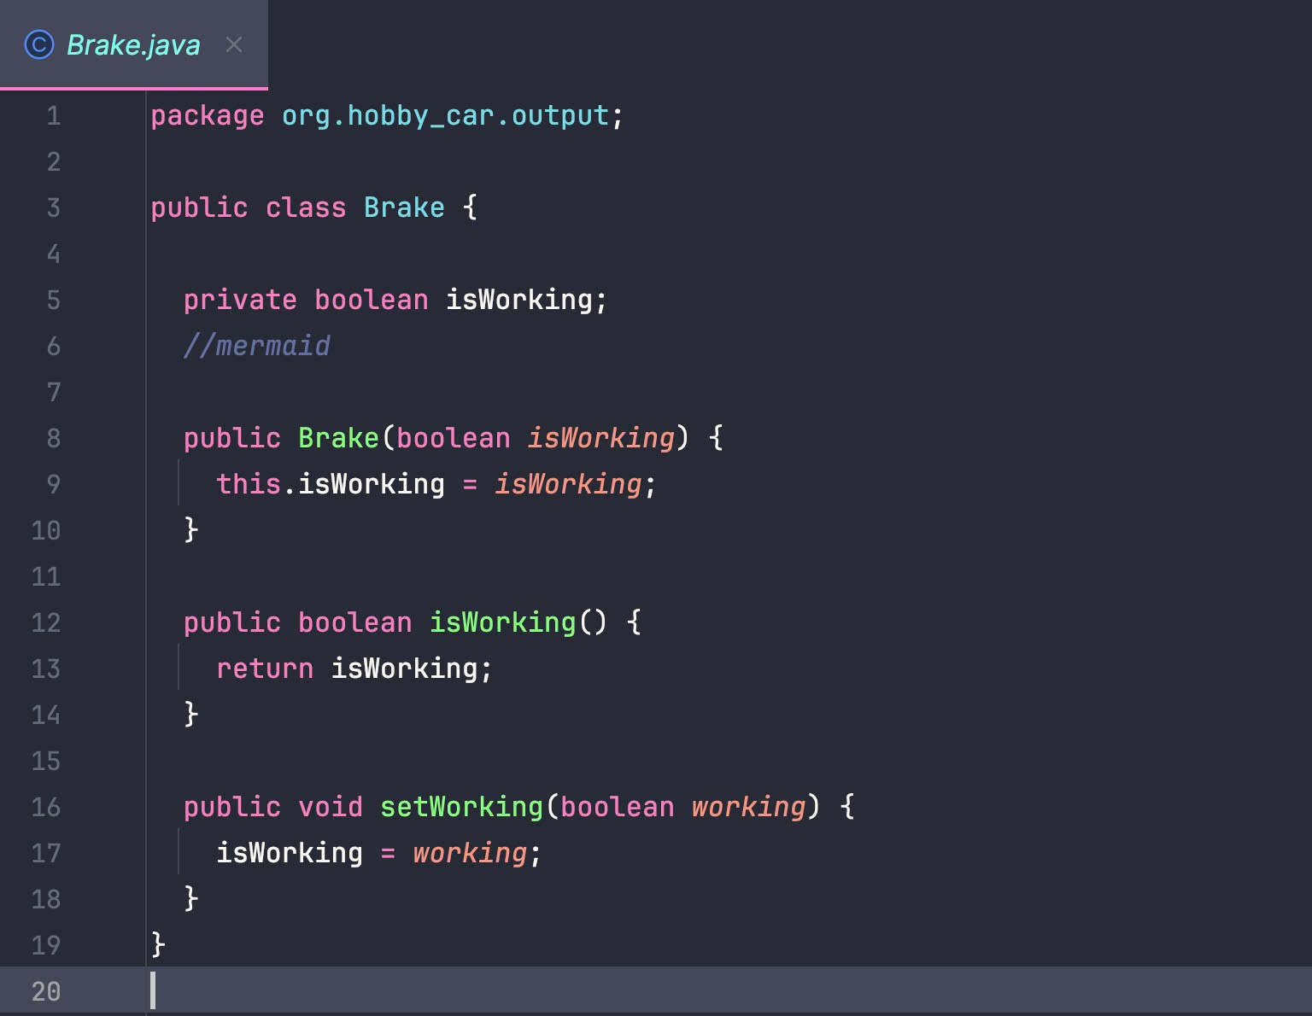

### 5.3.8. Class DCMotor

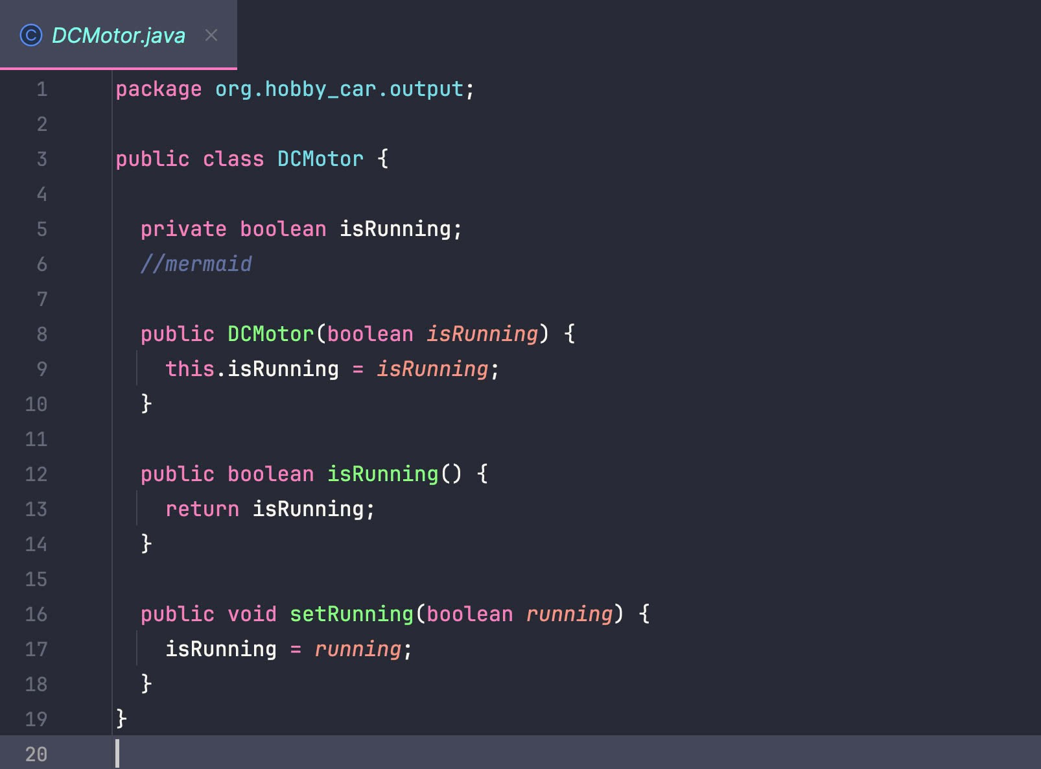

### 5.3.9. Class Camera

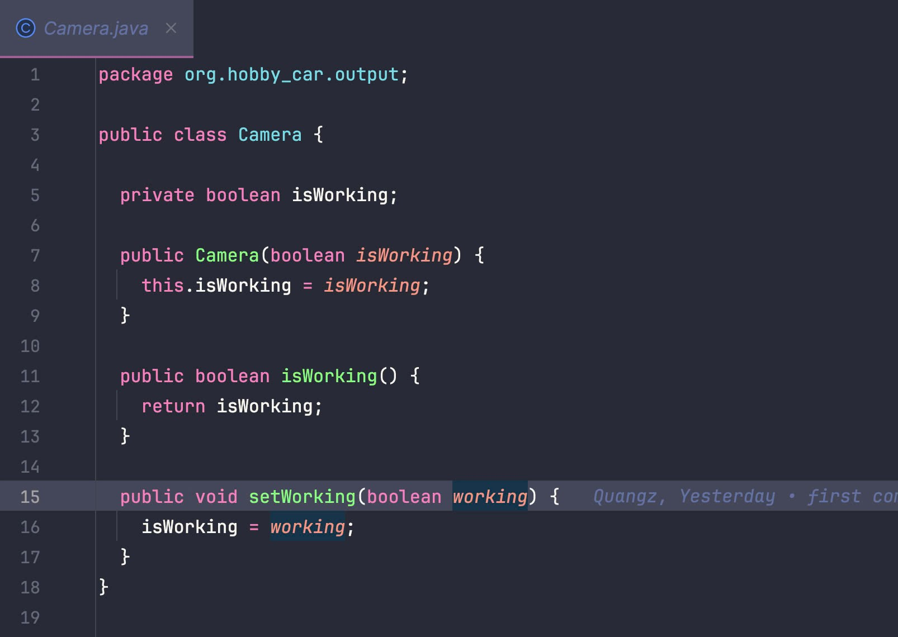

### 5.3.10. Class EncodedMotor

### 5.3.11. Class FetchAcceleratorPedal

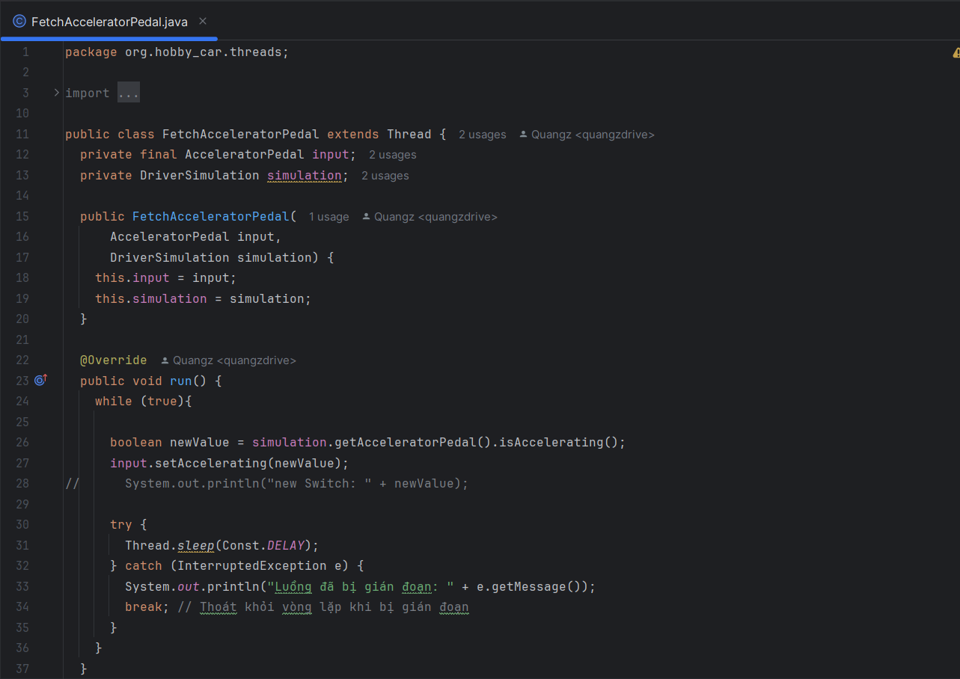

### 5.3.12. Class FetchBrakePedal

### 

### 5.3.13. Class FetchRemote

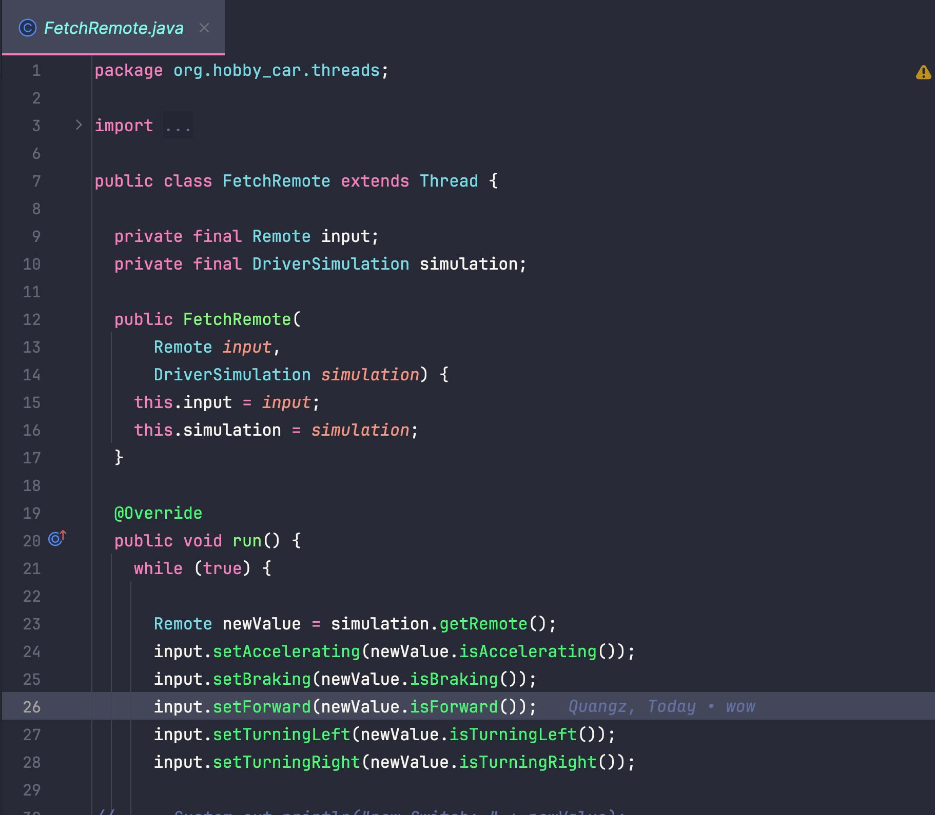

### 5.3.14. Class FetchChangeModeButton

### 

### 5.3.15. Class FetchSteeringWheel

### 5.3.16. Class FetchSwitch

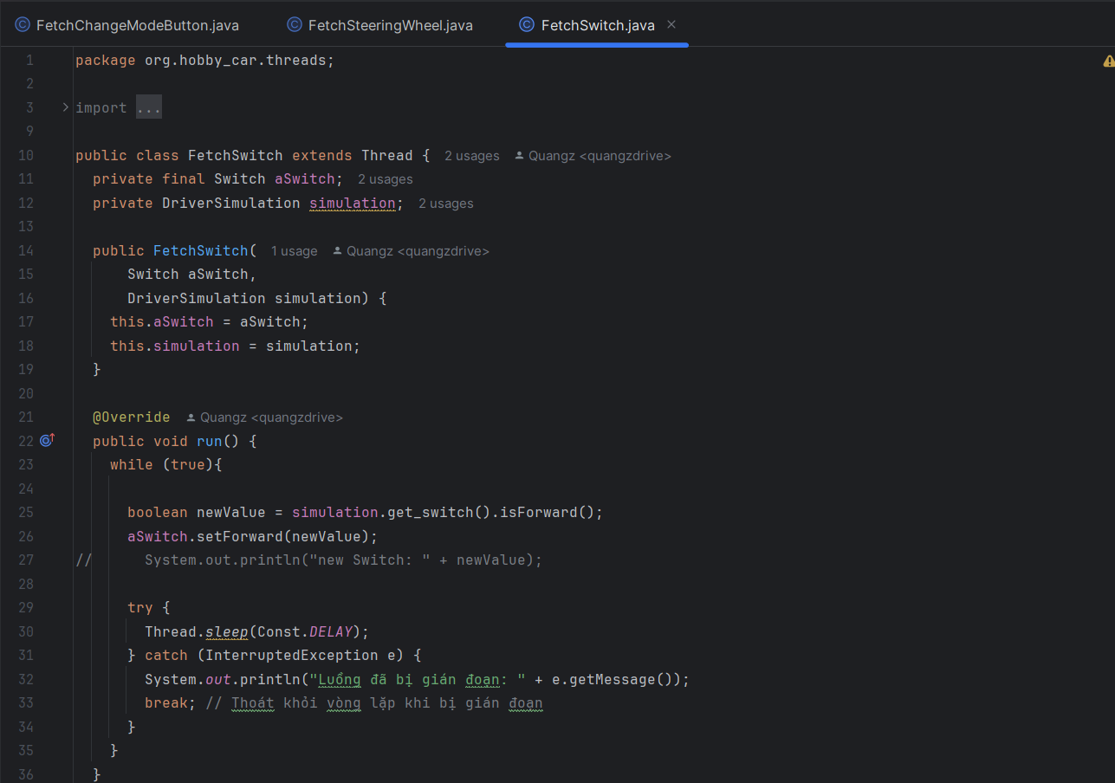

### 5.3.17. Class Controller

